

The Pioneer & World Leader in Melt Filtration Technology

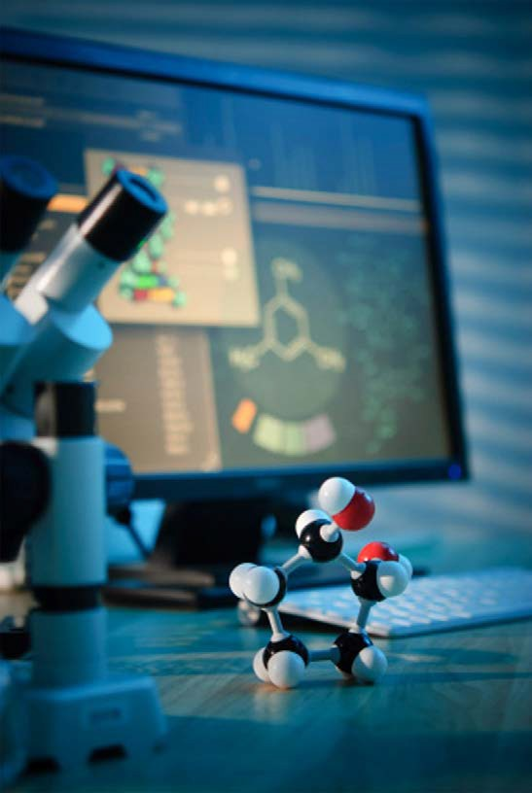SELEE Corporation,
from its inception, instinctively created an atmosphere to promote innovation.

The products themselves were not made to fill a void in the metal industry but to make your metal production process the best in the world. For more than four decades, SELEE® filtration systems have established a higher standard that today leads the industry worldwide.

SELEE’s consistent growth has been propelled by its corporate philosophy of continuous improvement, which demands “an obsessive commitment to customers that is paramount in all considerations.”

Our Mission
To be the most respected and innovative supplier enabling our customers to create advanced metal components for the transportation, agriculture, and consumer products industries.

Our Vision
We will be the revolutionary force in product innovation for the molten metal industry. Our brand will represent quality and innovation that rivals any company anywhere.

Our Core Values
Integrity: We are committed to fostering an environment that promotes honesty and respect.

Caring: We will be caring and attentive to the well-being of our employees, customers, suppliers, community,
and investors.

Responsive: We will utilize an adaptable, empowered, self-motivated work force to respond to opportunities and challenges.

HISTORY

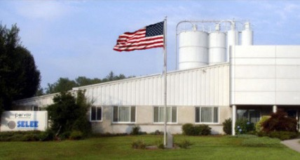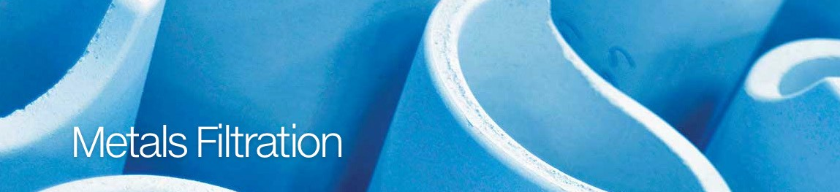SELEE Corporation, located in Hendersonville, North Carolina, is the world’s leading manufacturer
of ceramic foam. SELEE pioneered ceramic foam technology in the mid- 1970s and has successfully
developed a reputation for quality, service, innovation and technical leadership.

The foundation of SELEE was the development of this unique continuous open ceramic foam structure for use as a filter medium. As a result of this development, SELEE received the Industrial Research and Development I•R 100 Award in 1978 for “one of the most significant new technical innovations of the year.”

Move to Hendersonville, NC
During the late 1970s, rapid and successful introduction of the SELEE® filter to the aluminum industry quickly stretched the capacity of
the initial pilot facility in St. Louis, Missouri. As a consequence, a new and larger plant in
Hendersonville, North Carolina was commissioned in May 1979. All operations of the SELEE business
including sales, marketing, engineering, research and development and general administration were subsequently relocated to Hendersonville.

In the mid-1980s, an ambitious program was launched to expand the SELEE product
line. Nonferrous metal filtration technology was expanded and ferrous metal filtration products were developed for the iron and steel industry. During this period,
SELEE doubled its production capacity.

Up until January 1987, SELEE had operated as the Ceramic Foam Filter division of Consolidated Aluminum Corporation. On January 1, 1987, SELEE was spun off from Consolidated Aluminum to become a wholly owned subsidiary of Alusuisse-Lonza, a multi-billion dollar, multi-national Swiss corporation with extensive holdings in the metals, mining, chemicals and packaging industries.

During the late 1980s, new products for thermal processing, biotech, chemical and emission control applications were introduced. SELEE again expanded its manufacturing facilities and constructed a new technology center with a comprehensive pilot plant and extensive research and development laboratories. Also in the late 1980s, manufacturing and direct marketing operations were established in Europe, Brazil and Australia. In 1989, SELEE de Venezuela, a manufacturing joint venture, was formed.

ISO 9001 Certification
In 1990, SELEE received ISO 9001 certification – one of the first
500 companies in the United States to be awarded this certification.

In 1992, a group of key employees, with the help of several outside investors, purchased SELEE Corporation and its Venezuelan joint venture from Alusuisse-Lonza. Subsequently in 1995, SELEE joined Porvair plc and became part of Porvair Corporation in the United States maintaining its strong position as SELEE in the melt treatment and filtration industry. Porvair Advanced Materials, Inc. was spun off from SELEE Corporation and Porvair Corporation in December 1997 broadening its marketing base into liquid and gas filtration, environmental, thermal, chemical and catalysis applications.

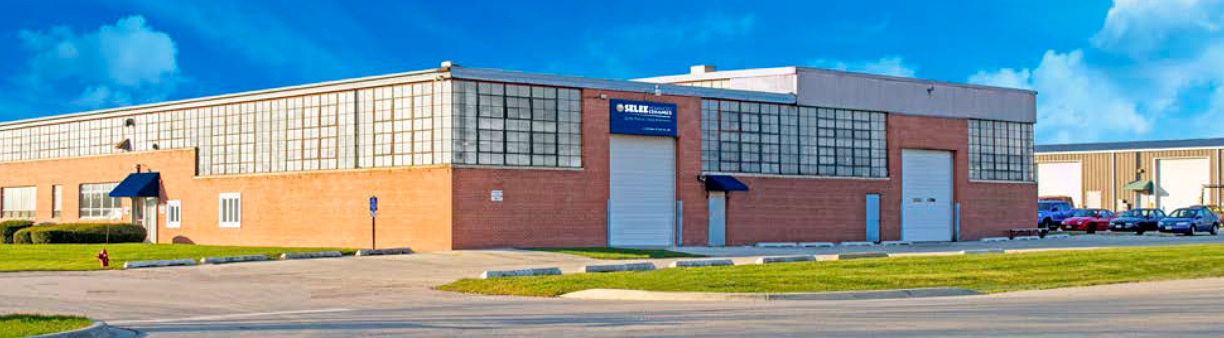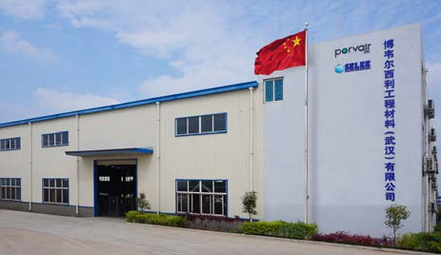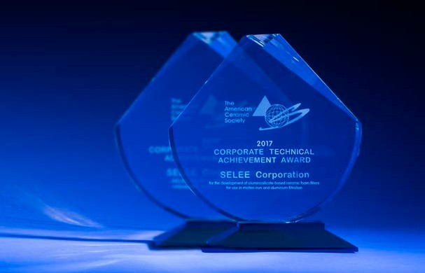

Acquired Engineered Ceramics®
In 2001, SELEE Corporation acquired Engineered Ceramics® in Gilberts, Illinois from SPX-Lindberg. Now having become SELEE® Advanced Ceramics® , and it is a highly innovative company and

world leader in molten metal containment technologies that targets the fast growing nickel based superalloy investment casting industry. The combination of SELEE® Advanced Ceramics® technologies, and SELEE’s award winning customer and technical service has proven to be an excellent combination.

Since its inception, SELEE’s business has grown to well over 500 customers. SELEE’s innovative products are currently being sold in 50 countries around the world. SELEE, like its parent company, Porvair plc, holds a strong competency in research and development, having pioneered virtually all of the new technological innovations in the ceramic foam filter industry.
SELEE reinvests a significant percentage of every sales dollar back into the research and development of new advanced material technology. SELEE’s 23,000 square foot technology center and pilot plant spearhead new product development, as well as improvements in existing products. SELEE is constantly looking for products and processes which provide a technical edge and opportunities for growth. Customer support includes an experienced staff of degreed metallurgists as Applications Engineers, a metallurgical lab, SEM, and X-ray diffraction.
From a quality standpoint, SELEE has achieved several prestigious, internationally recognized quality rankings. SELEE was one of the first U.S. firms to be certified ISO 9001 as well as receiving Ford Q1 certification. In 1996, SELEE was one of the first companies in the
U.S. to be certified to QS 9000. SELEE also achieved ISO 14001 certification in 2002. SELEE continues to maintain its strong quality system through ISO 9001:2015.

Built China Manufacturing Facility
In 2009, recognizing the importance of the China metals casting industry, SELEE formed Porvair SELEE Filtration Technology (Hubei) Co., Ltd. The new facility was designed to build filters for the iron foundry industry, and after four years of continuous improvement in productivity and sales, a new larger facility has been built to produce products for both the iron foundry and aluminum cast
house markets.

ACerS 2009 Environmental &
2017 Technical Achievement Awards In 2009, SELEE received the Corporate Environmental Achievement Award from The American Ceramic Society. This award honors a single outstanding environmental achievement made by an ACerS corporate member in the field of ceramics. SELEE received its award for the development
of porous reticulated ceramic foam filters.

APPLICATIONS

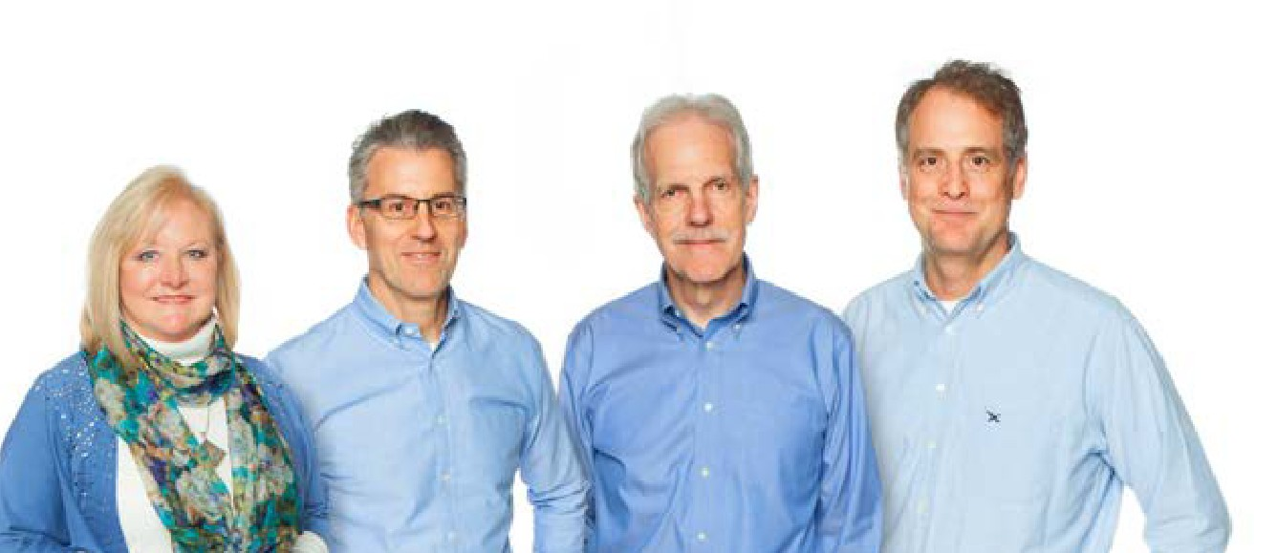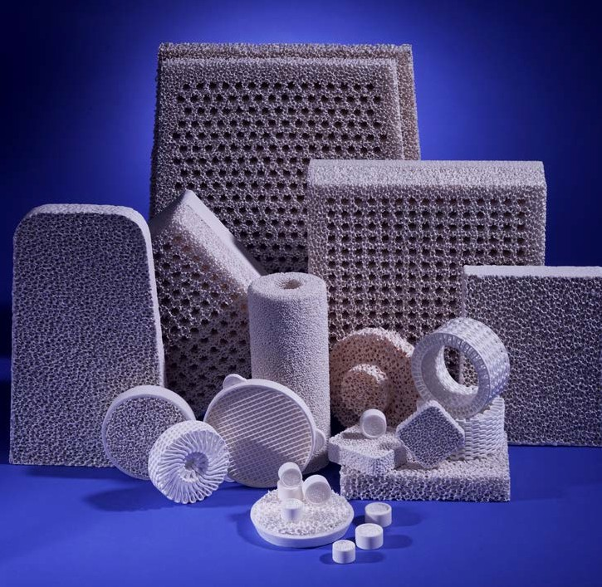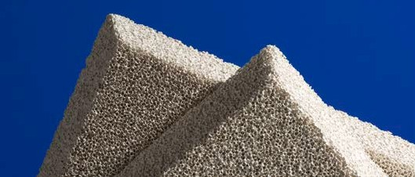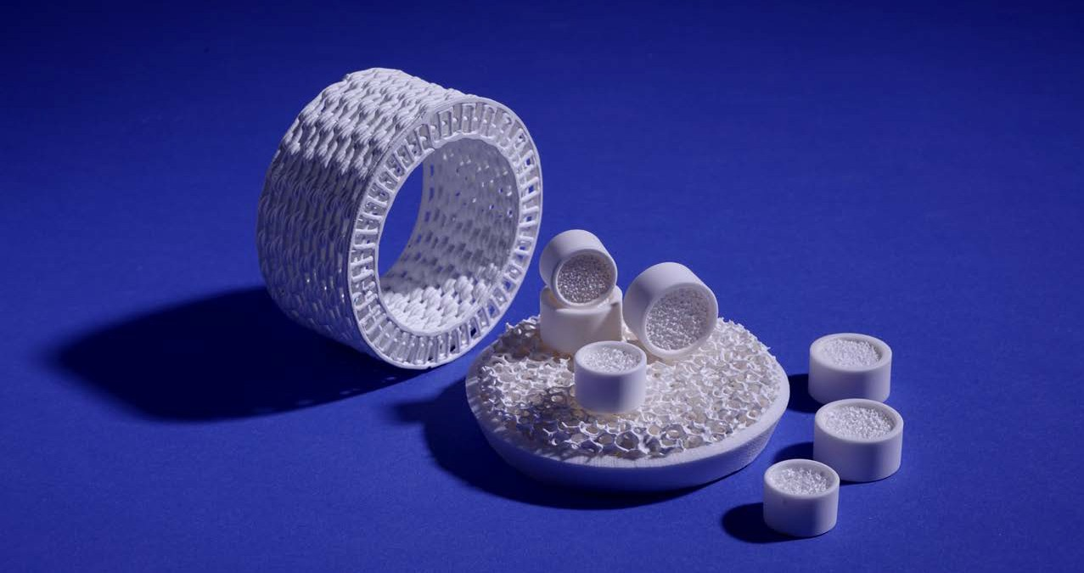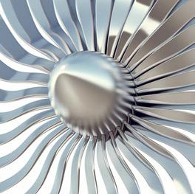SELEE® pioneered the use of ceramic foam in metal filtration technology. As a result of this commitment to innovation, SELEE remains consistently at the forefront of the latest developments in filtration, melt treatment and transfer processes for molten metals of all types.

We are very proud of our long term commitment to customer service, product quality, leading edge innovation, and technical support for our valued customers.

Exceptional Filtration Products SELEE is a technical ceramics company specializing in the design and manufacture of porous technical ceramics and metal foams for a wide range of demanding industrial applications. We are the world leader in melt filtration technology.

Providing Service and Support Our company leverages the application knowledge built by our world class engineers and researchers over the past three decades, and utilizes our world- wide network of independent experts and consultants.

Meet Our World Class Team We strive for expertise not only in what we do, but first and foremost in what our customers do. That’s
why our Customer Technical Support staff includes Masters and PhD level Metallurgical and Materials Engineers.
Investment Casting SELEE offers the knowledge and expertise of metal processing needed to provide optimal solutions for the unique filtration challenges of the Investment Casting industry.

SELEE® Advanced Ceramics® division provides the best value in standard and custom- designed ceramic shapes for molten metal handling in the investment cast house.

- Filters
- Metal Handling Products

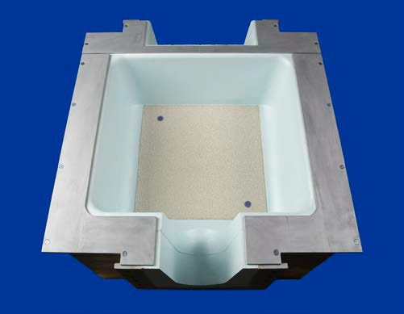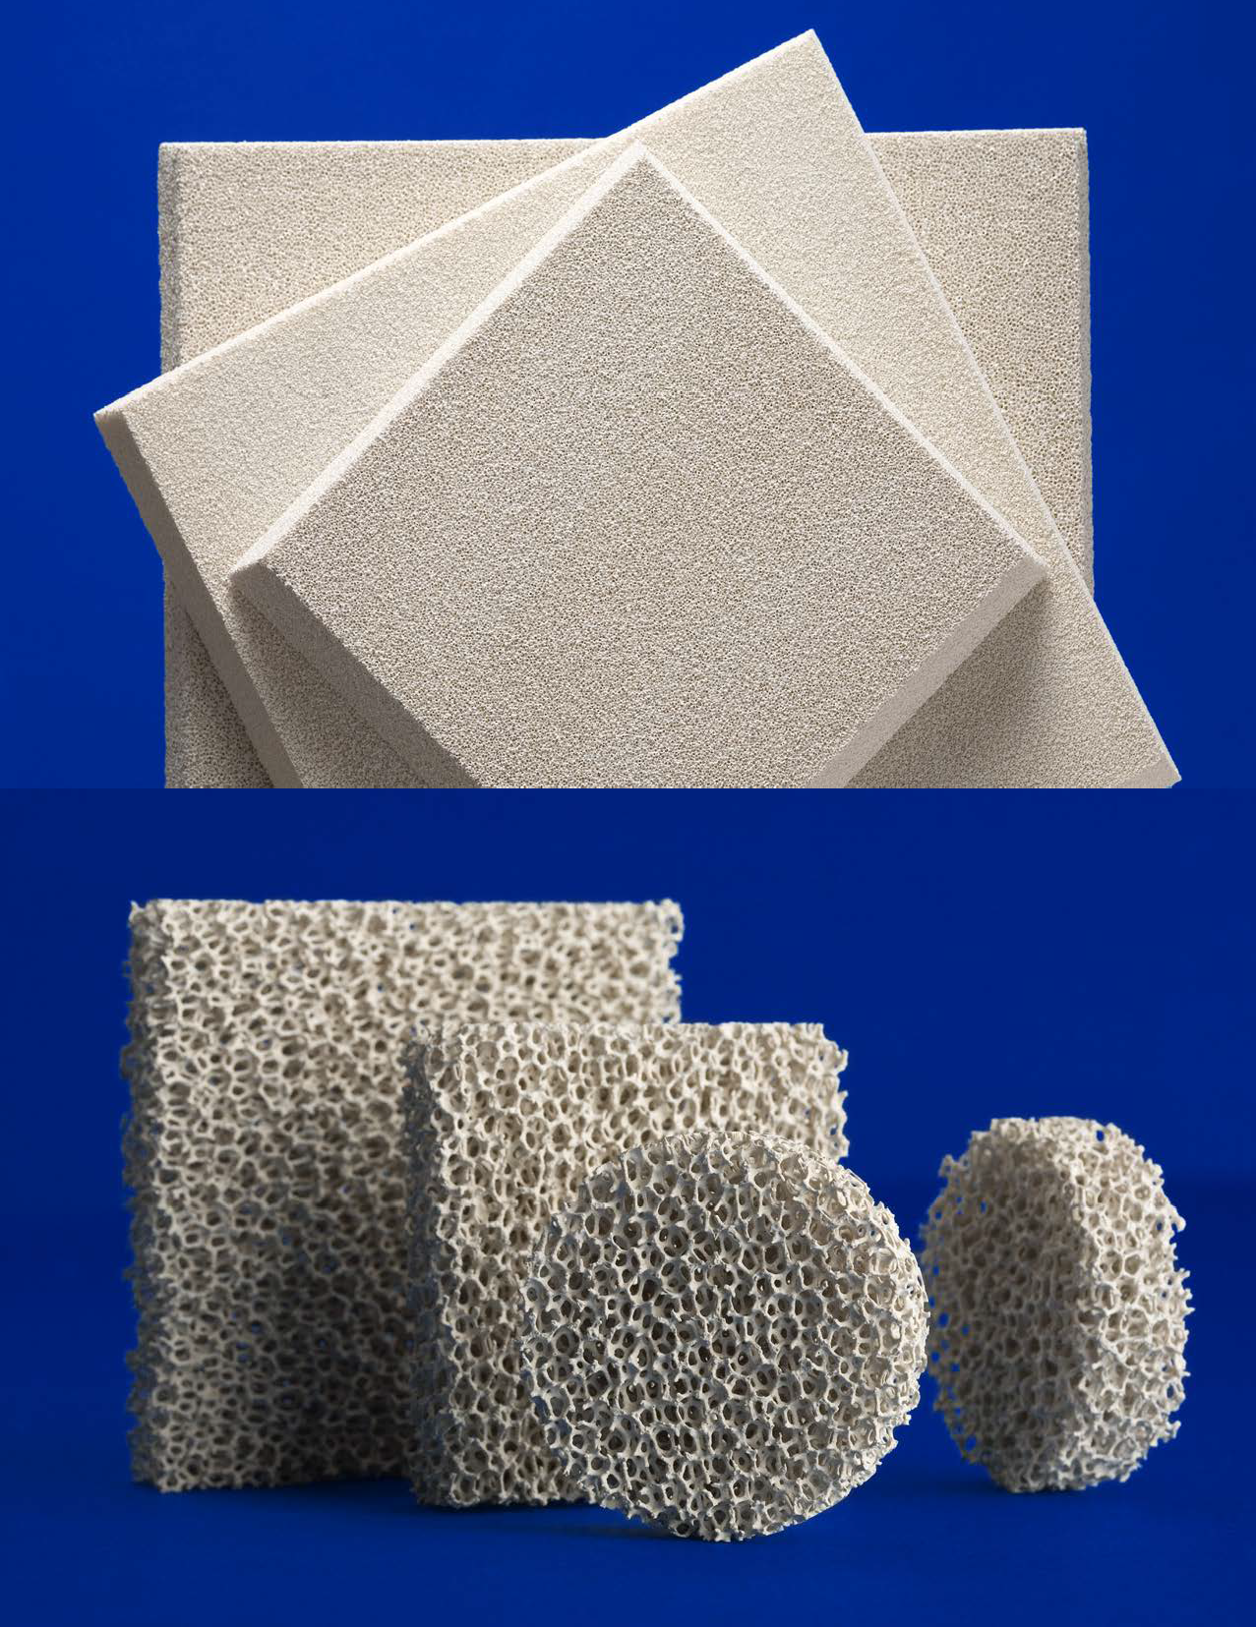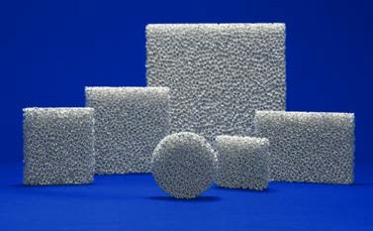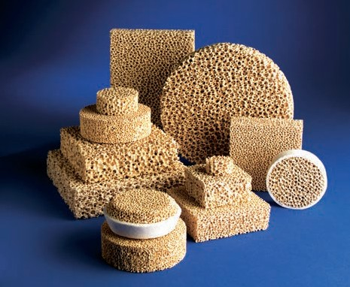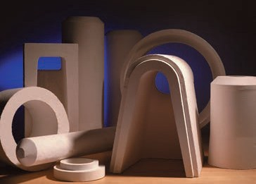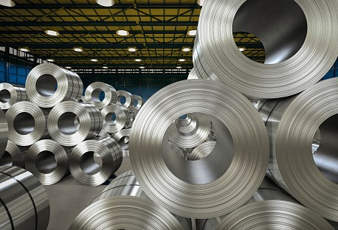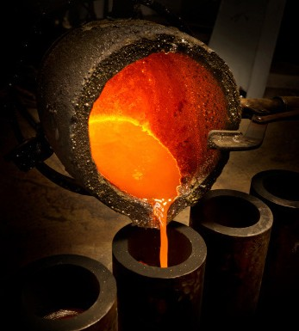

Aluminum Cast House
SELEE Corporation invented the concept of using ceramic foam as a filter media for molten aluminum.

We are at the forefront of developments in the aluminum filtration, melt treatment and molten metal transfer processes.

SELEE® offers a complete line of products
for this market.

- Ceramic Foam Filters
- Preheat Systems
- Advanced Ceramic Shapes

Foundry
SELEE products for metal filtration in foundries are as varied as the metals for which they are designed.

Compositions range from silicon carbide and alumino-silicate for iron and aluminum filtration to high-purity zirconia for steel.
- Aluminum
- Iron
- Steel
- Copper/Magnesium

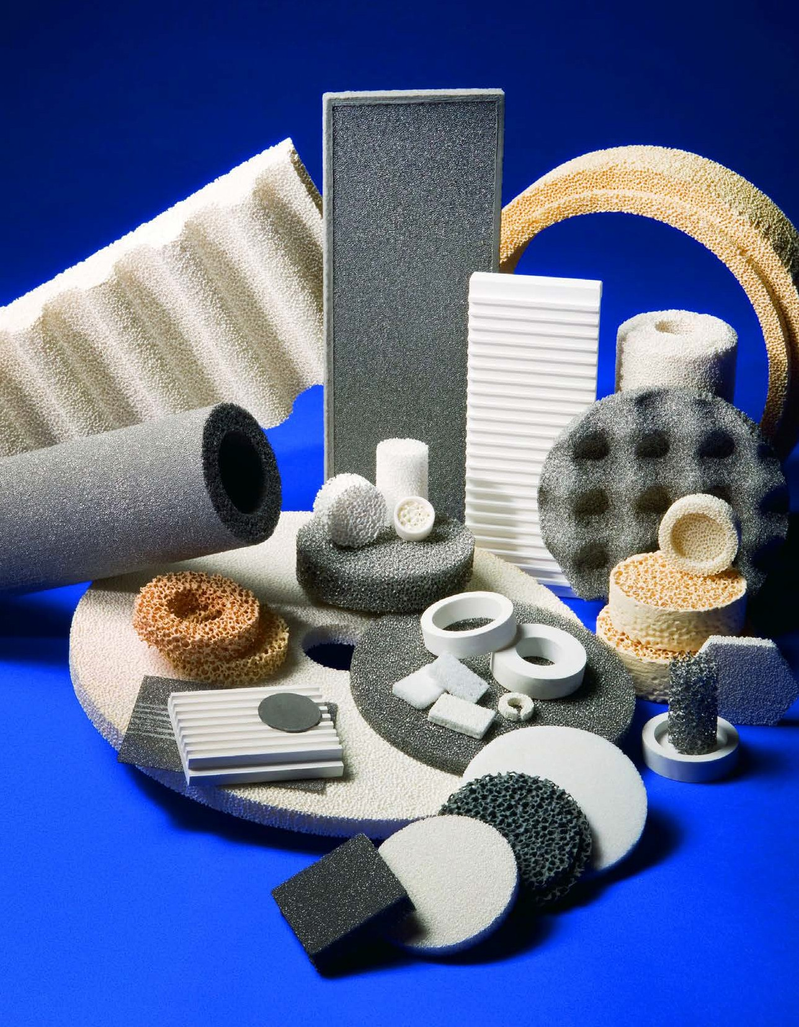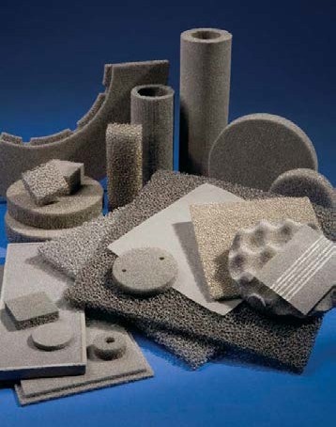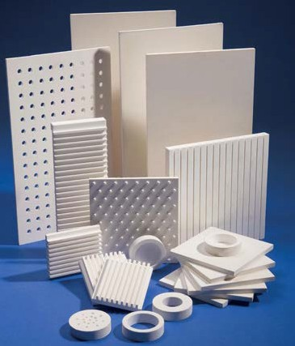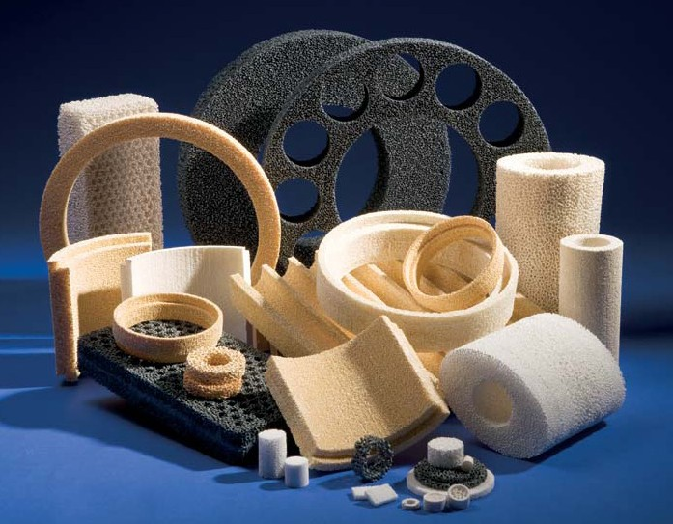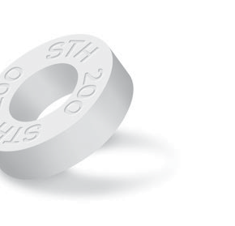Custom Filtration Products
Matrix®, Metal Foams, Carbon Foams

SELEE® Matrix® filters offer investment casting foundries reduced metal flow rate variability resulting in operational performance benefits.

Thermal
Processing Products
We offer a complete line of kiln furniture, kiln components and accessories, everything from dense to low mass products to meet every application need. Our complete line of kiln components will provide a solution for every rebuild project along with applications engineering assistance
for special design requirements.

Metal Foam
Common alloy materials include stainless steels, iron-chromium alloys, and copper alloys. Uses for metal foam include radiant burners, catalyst supports, flame arrestors, static fluid mixers, and water treatment media, among many others.

Carbon Foam
SELEE® carbon foam is an open-cell reticulated carbon foam with highly controlled pore size and porosity. Applications include electrodes, catalyst supports, high-temperature filtration, and high-temperature thermal insulation.

Temperature Rings
Reliable, repeatable firing is absolutely critical to producing today’s high quality components. The use of Process Temperature Control Rings (PTCR) give
our customers PTCR gives our customers a highly accurate representation of firing conditions. Unlike other, more traditional methods, the PTCR system measures the actual amount of heat that is transferred
to the fired products; thus allowing the mapping of the kiln’s thermal performance. Through application of PTCR technology, our customers have experienced yield improvements, reduced inspection costs and overall quality improvements.

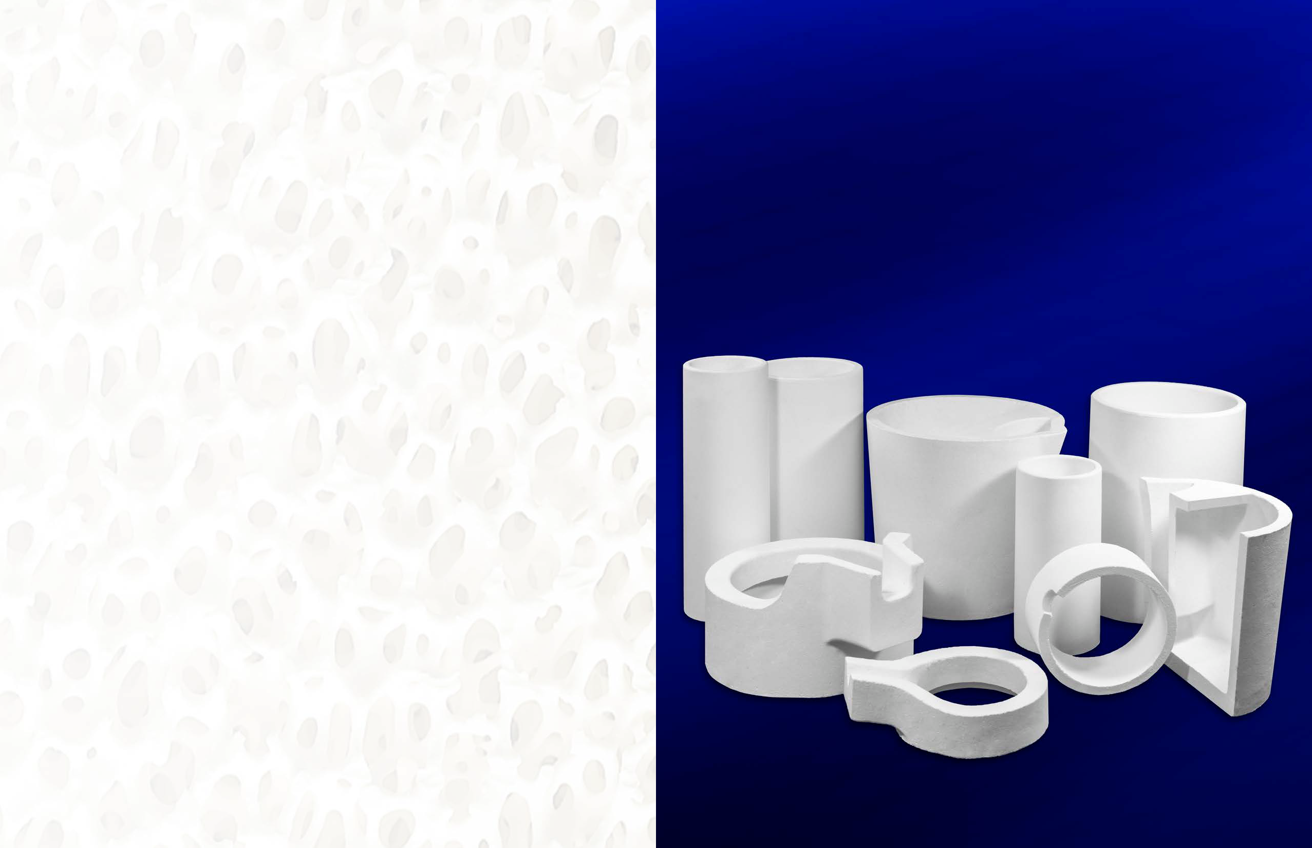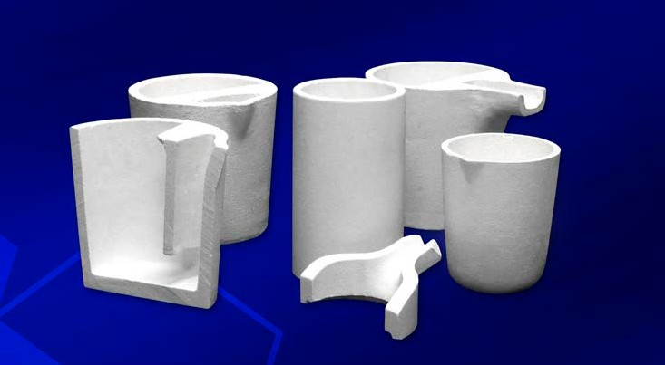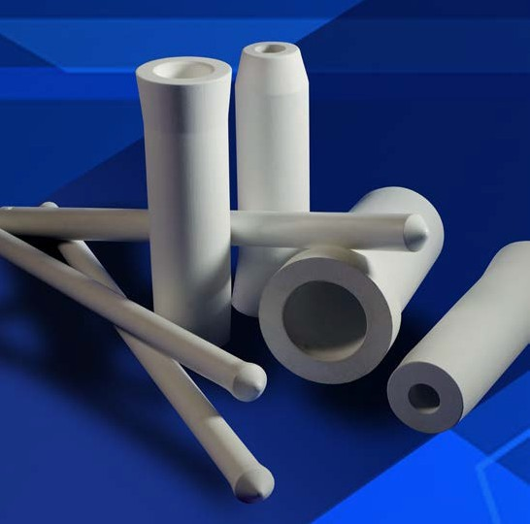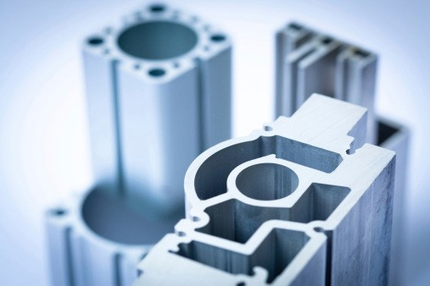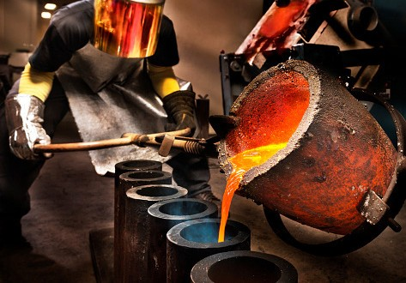Metal Handling Products SELEE® Advanced Ceramics® division offers a wide variety
of metal handling products. The quality of our prefired materials results in spill-free refractory products with consistent performance, outstanding thermal shock resistance,
and long life.

Crucibles
Designed for integrity and
performance, our crucibles can have dramatic effects on the cost effectiveness of your shop. Crucibles are available in a wide selection of shapes and melting capacities. For extended crucible life and performance, let our engineering team assist
you with technical advice on proper selection, correct installation and sound operational practices.

Ladle Liners
SELEE® Advanced Ceramics® ladle liners, in a large variety of sizes and spout configurations, are strong and efficient, innovative in design and consistent in their high performance. Choose from open-top or our unique monolithic bottom-pour ladle liners with integrated skimmers.

Spouts
Our unlimited custom shape capabilities distinguish us from the competition with spouts and integral crucibles tailored to the needs of your shop.
If sizing changes, spout modifications, or alterations are necessary to improve your process, you can count on us to provide you with prompt and effective solutions.

Pak-Tite Rams
These high-thermal expansion, dry vibratable ramming materials pack easily and provide maximal density with minimal shifting. Pak-Tite rams are designed for use with SELEE® Advanced Ceramics® crucibles and ladles and are available in silica and spinel formulations.

The combination of SELEE® Advanced Ceramics® technologies, and SELEE’s award winning customer and technical
service has proven to be an excellent combination.

Metal Filtration Systems
The pioneer in Melt Filtration Technology is also your metal filtration systems source. For optimal metal cleanliness, SELEE® can provide the system, filters, operational practices, metallurgical services, and support. Let the experienced team of SELEE engineers analyze, service, and design your metal filtration system.
SELEE can provide you with individual system components or a complete package to meet your filtration needs.

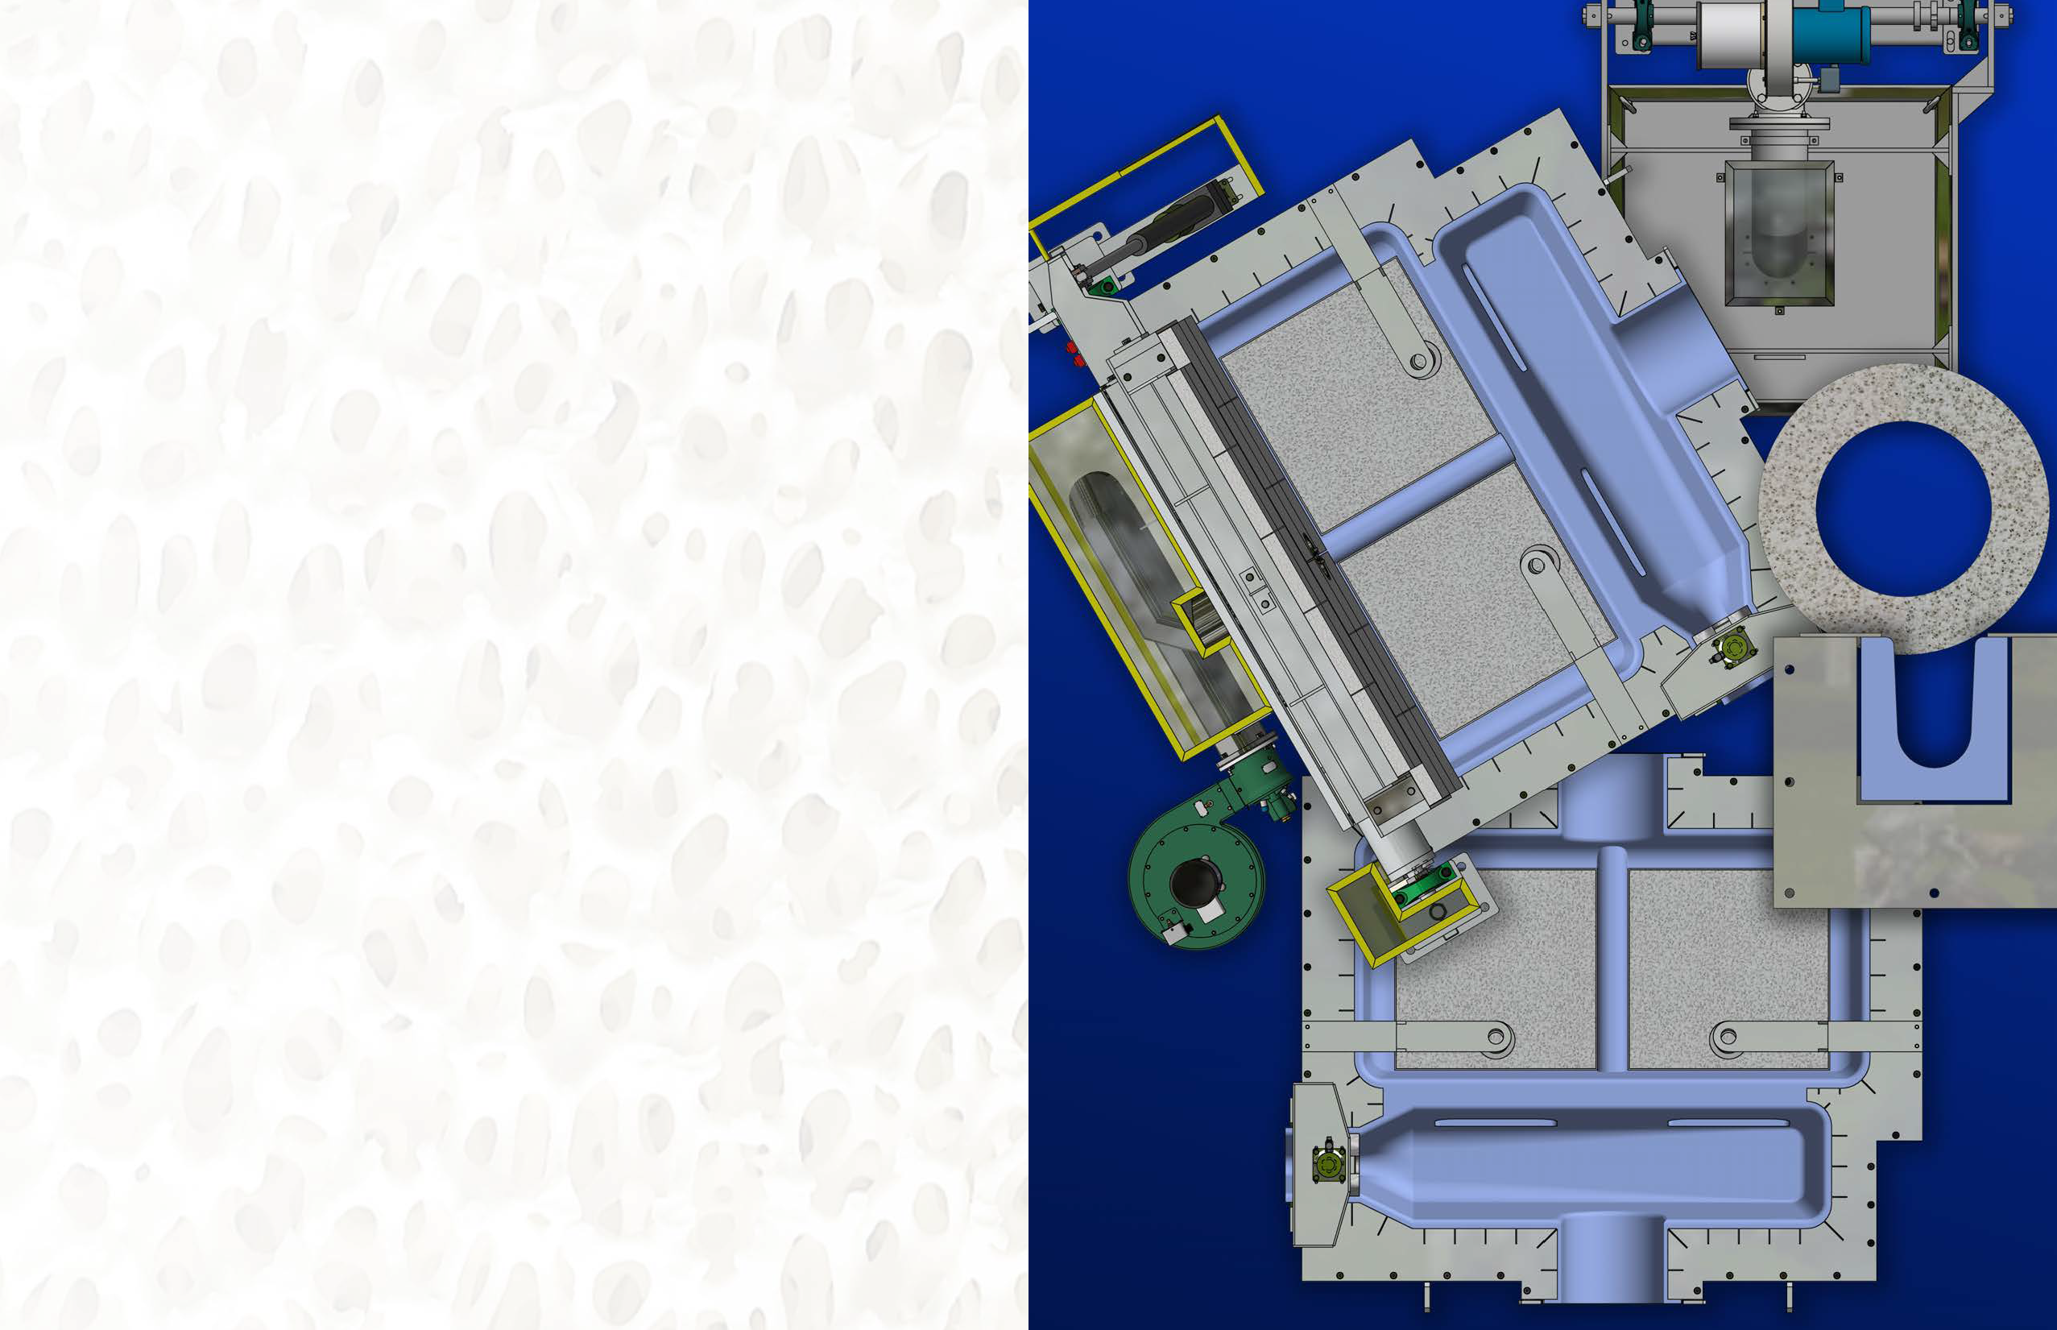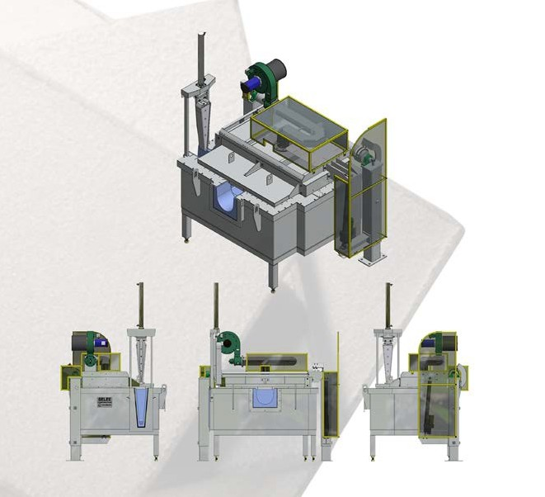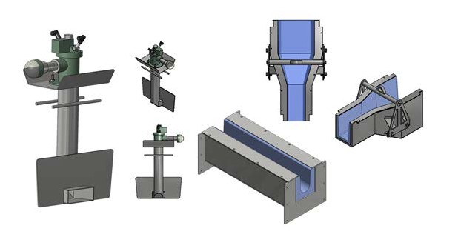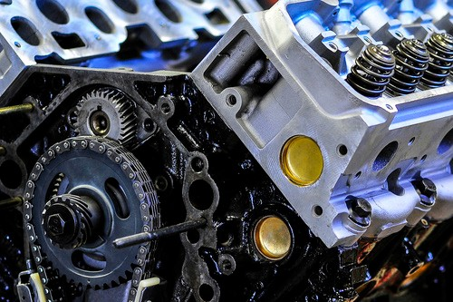

FEATURES AND BENEFITS:
- Thermal-shock resistant
- Easy to clean due to design
- Non-wetting for longer life
- Corrosion resistant
- Insulating

TROUGHS/LAUNDERS
Our Troughs and Launders use Fused Silica and are non-wetted to the molten aluminum alloys, which is a result of our use of proprietary non-wetting additives.

FEATURES AND BENEFITS:
- Corrosion resistant
- Insulating
- Thermal-shock resistant
- High Strength
- Lower Thermal Diffusivity

Filter Bowls/Boxes
SELEE’s precision-engineered filter bowls are unique. Their development and design are based on our own metallurgical engineers’ years of experience in the field of aluminum melt filtration and molten transfer technology. SELEE utilizes an innovative fused silica material in designing the filter bowls. The filter bowls can be ordered as Single, Duplex, Triplex, Staged or can also be custom-designed.

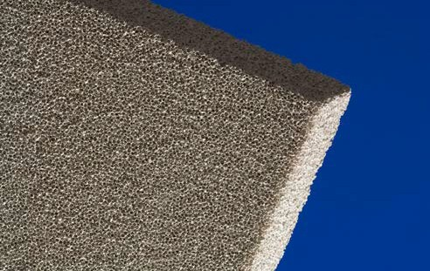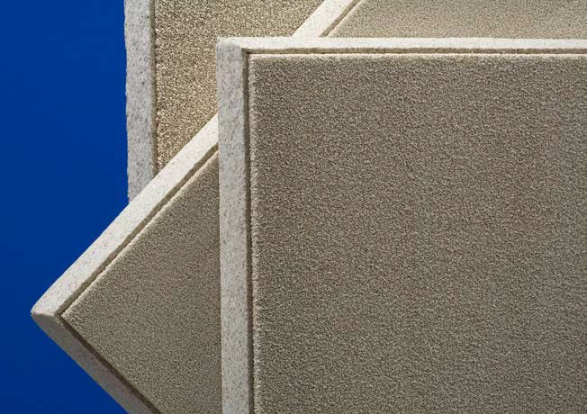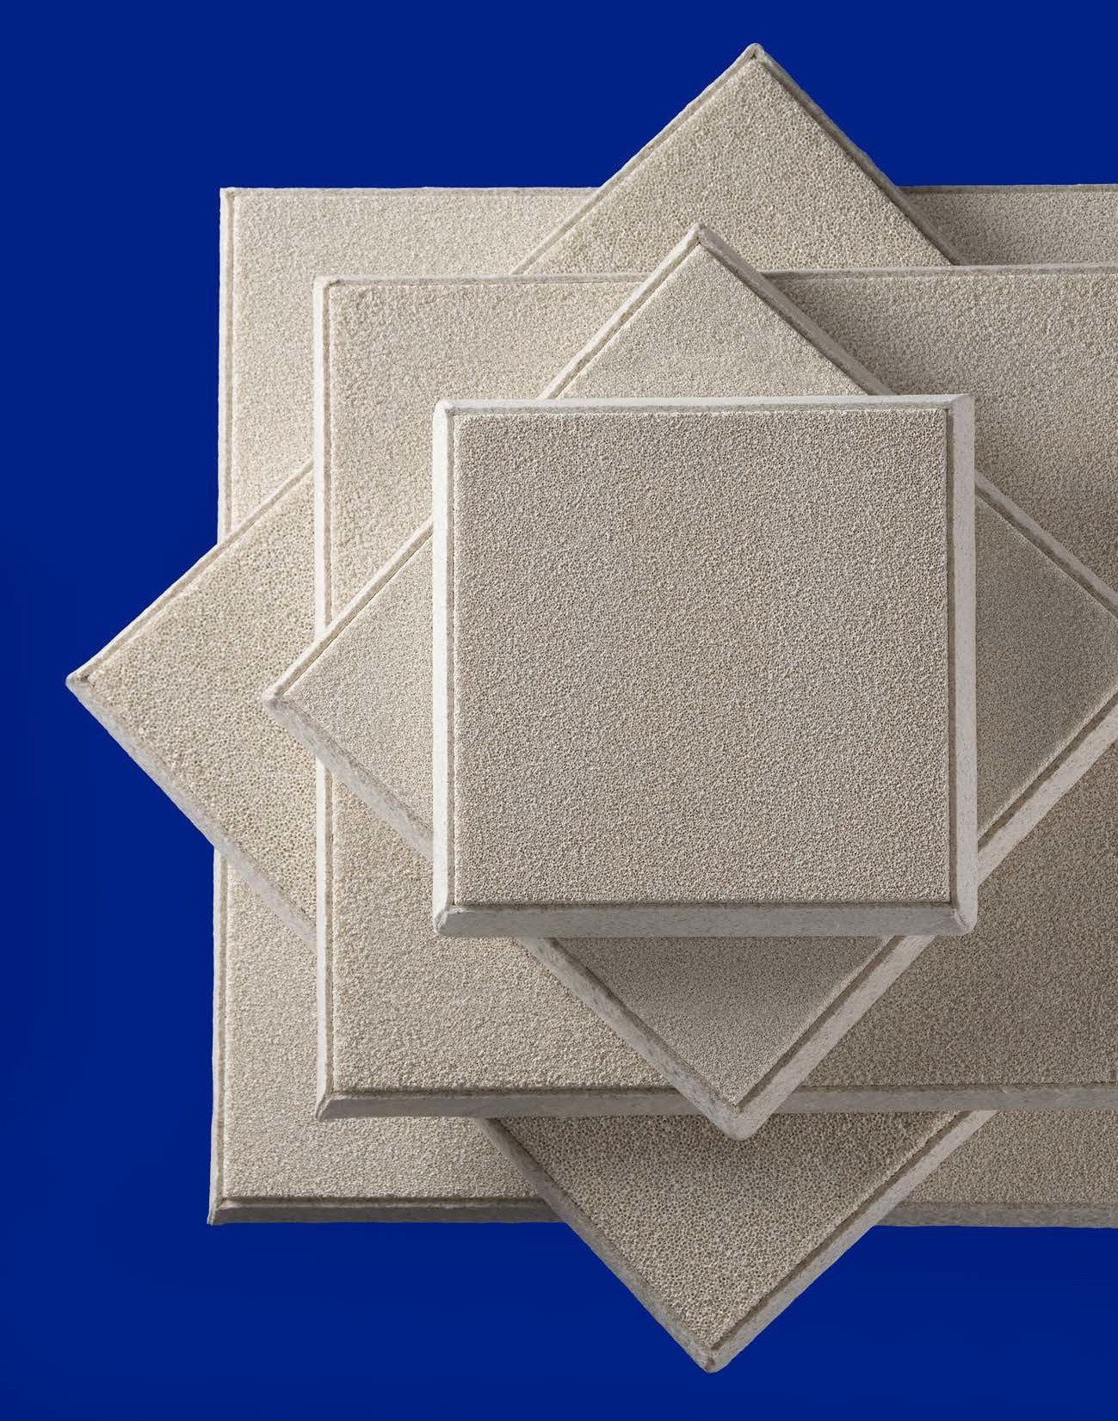SELEE® CS-X® - The Next Generation Cast House Filter

SELEE® CS-X® CAST HOUSE FILTER WINS
2017 ENVIRONMENTAL ACHIEVEMENT AWARD
SELEE Corporation invented the ceramic foam filter in 1973 based on a phosphate-bonded alumina (PBA) structure. It has since been widely copied by other suppliers and has become the standard cast house filter in the industry, representing 98% of ceramic foam filters in use. In 2008 SELEE introduced CS-X®, the next generation ceramic foam filter
for aluminum cast houses, offering significant advantages over the current product.

SELEE continues to live up to its legacy as “The World Leader in Molten Metal Filtration Technology.”

SELEE® CS-X® offers the following key benefits over phosphate-bonded alumina filters:

Safer and more environmentally friendly
- Non-RCF Filter - No refractory ceramic fibers in the filter body or gasket

- Elimination of phosphine gas generation from used filters in the cast house
and in disposal

Superior filtration performance
- More stable filter-metal interface resulting in better inclusion adhesion
- Significant reduction in filter-metal reaction and associated inclusion releases in magnesium alloys
- Elimination of hydrogen pick-up across the filter
- Reduction in filter cracking during preheat and operation resulting from high thermal expansion
- Improved thermal shock resistance

Transparent changeover for cast houses
- Same dimensions and pore sizes as current filters
- Same preheat, bowls, and operational characteristics

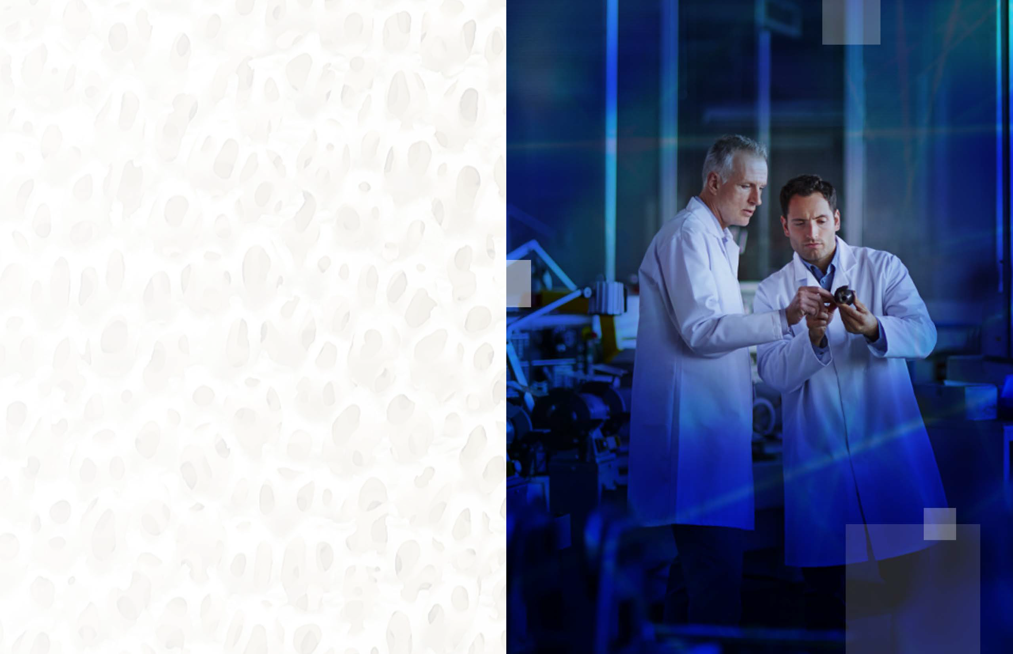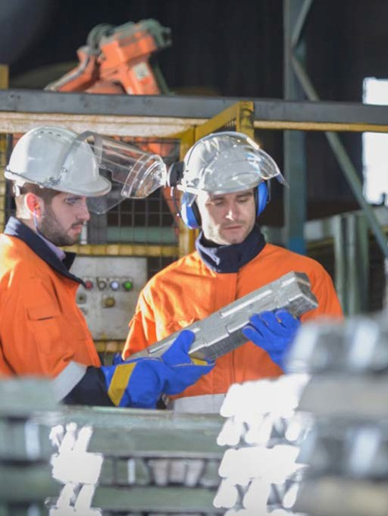SERVICES

Metallurgical Analysis

At SELEE®, we do much more than just sell products. Our team of world class engineers stands ready to assist you in all facets of molten metal processing, insuring that you have the knowledge you need to consistently produce the highest quality products with optimal cost efficiency.

SELEE Metallurgical Services (SMS) is an independent business unit offering metallurgical services and advice to the molten metal industry. SMS leverages the application knowledge built by our world class SELEE engineers and researchers over the past three decades and utilizes our worldwide network of independent experts and consultants. SMS pulls together the right
project team to address the client’s specific issues. This is all done under SELEE project management to insure professional project delivery, confidentiality, and quality.

SMS focuses on the core customer base of aluminum cast houses, foundries (aluminum, iron, steel, copper), and investment casting; with specific focus on the furnace to mold/casting processes. SMS is a virtual, but independent entity of SELEE Corporation.

EXAMPLES OF SELEE METALLURGICAL SERVICE OFFERINGS INCLUDE:
- Defect analysis, root cause investigation, and identification of corrective actions
- Metal quality assessment
- Recommendations for achieving new product quality requirements
- Process audit – best practices and employee training
- Ceramic materials selection
- New process design

SMS can also offer outsourcing of client laboratory services.
Metal manufacturing and fabrication companies may find it economically beneficial to outsource variable lab support services rather than financing the fixed cost infrastructure.

Customer Service
Our dedicated Customer Service Department will answer your calls weekdays between 7:00 AM and 5:00 PM Eastern Standard time. At other times, our voice message system will help you get the quickest possible response.

Call now to place your order...

Global Sales
All of us at SELEE stand behind our products with a global commitment to outstanding service. Our products can improve your products, your processes, and your bottom line. Our Global Sales Team welcomes your questions, requests and problems because we are dedicated to finding answers and meeting your needs.

Meet our team ...

Callers within the US: +1-800-842-3818

International callers: +1-828-693-7785 or E-mail: customerservice@selee.com

Customer Service Team:

Joy Latta
Demand Process & Logistics Manager Email: jlatta@selee.com
Direct Line +1-828-694-3332

Pamela Banks
Product Coordinator - Iron/Aluminum Foundry Email: pbanks@selee.com
Direct Line +1-828-694-3366

Rebecca Sherman
Product Coordinator – Cast House Email: rsherman@selee.com Direct Line +1-828-694-3334

Deanna Horwitz
Product Coordinator – HTP (High Temperature Products) Email: dhorwitz@selee.com Direct Line +1-828-694-3309

Flor Pickus
Product Coordinator – Super Alloy Filtration Email: fpickus@selee.com
Direct Line +1-828-694-3306

Wuhan, China
Chong (Tina) Tang
Wuhan Office:
508, Unit A, Building 3,
Huifeng Enterprise Headquarters Nanniwan Avenue
Qiaokou District Wuhan 430034 China
Email: psam@selee.com (Office) +86-27-83311026
(Fax) +86-27-83311099

Ruiwen (Sunny) Xie
Wuhan Office:
508, Unit A, Building 3,
Huifeng Enterprise Headquarters Nanniwan Avenue
Qiaokou District Wuhan 430034 China
Email: psam@selee.com (Office) +86-27-83311026
(Fax) +86-27-83311099

Kiro Qu
Wuhan Office:
508, Unit A, Building 3,
Huifeng Enterprise Headquarters Nanniwan Avenue
Qiaokou District Wuhan 430034 China
Email: psam@selee.com (Office) +86-27-83311026
(Fax) +86-27-83311099
Watt Jackson
President, Global Commercial Operations Email: wjackson@selee.com
Office phone: +1-828-694-3321

Leonard Aubrey
Vice President, Application Engineering Email: laubrey@selee.com
Cell: +1-828-699-1325

Feng Chi
Aluminum Cast House Development Engineer Email: fchi@selee.com
Cell: +1-828-435-0284

Robert Appling
Product Manager - Foundry and Superalloys Email: rappling@selee.com
Cell: +1-216-339-2971

Ramon Duque
Regional Sales Manager Email: rduque@selee.com Cell: +1-828-674-7744

Mark Heamon
Product Manager -
Cast House and New Products Email: mheamon@selee.com Cell: +1-770-329-5373

James Schmahl
Product Manager – Foundry Email: jschmahl@selee.com Cell: +1-608-575-5514

Wang Li
Sales in China
Email: psam@selee.com (Office) +86-27-83311026
(Fax) +86-27-83311099
Alexey Kuchmenko
SELEE Corporation (Russia)
Applications Engineer – Russia and Eastern Europe Email: akcuhmenko@selee.com
Cell: +7-916-498-8215
Fax: +7-498-720-6227

Shikai (Kaiden) Feng
Sales in China
Email: psam@selee.com (Office) +86-27-83311026
(Fax) +86-27-83311099

Ingo Schwarz
SELEE Corporation (Europe) Business Manager, EMEA Email: ischwarz@selee.com Cell: +49-172-2778131
Fax (US Customer Service): +1-828-693-1868

Guoqing (Evan) Xiao
Sales in China
Email: psam@ elee.com (Office) +86-27-83311026
(Fax) +86-27-83311099

Rong (Rocky) Huang
Application Engineer - Cast House Email: psam@selee.com
(Office) +86-27-83311026
(Fax) +86-27-83311099

Morgan Xia
Sales Manager - China and Southeast Asia Email: mxia@selee.com
(Office) +86-27-83311026
(Fax) +86-27-83311099

SELEE®Advanced Ceramics® - Gilberts, Illinois, USA
Kurt Schiefelbein
Investment Casting and
Kiln Furniture Product Manager Email: kschiefelbein@selee.com Cell: +1-262-210-0716



Hendersonville, NC USA

Mailing Address:
700 Shepherd Street Hendersonville, NC 28792, USA

Phone:
+1-828-697-2411 (Main)
+1-800-438-7274 (Main Toll-Free)
+1-800-842-3818 (Sales Toll-Free)

Email: customerservice@selee.com

Wuhan, China
508, Unit A, Building 3, Huifeng Enterprise Headquarters
Nanniwan Avenue
Qiaokou District Wuhan 430034 China

(Office) +86-27-83311026
(FAX) +86-27-83311099

Email: PSAM@selee.com

a member of plc

